

**Placement Empowerment Program**

***Cloud Computing and DevOps Centre***

Automate Static Website Deployment Locally Create a script that updates your server whenever changes are pushed.

**Name:Bhuvana K Department : CSE**

**Introduction**

Efficient deployment processes are crucial for maintaining up-to-date static websites. Automating the deployment of static websites ensures that the latest changes are reflected on the server as soon as they are pushed to the repository. This document outlines how to create a script that updates the server with new changes and restarts the necessary services, using Git hooks and scripting techniques.

**Objectives**

**•** Understand the use of Git hooks for automating deployment.

• Learn to write scripts for pulling changes and managing server services.

• Automate the deployment process to minimize manual intervention**.**

**Understanding Key Concepts**

• Git Hooks: Scripts that Git executes automatically on specific events like commits or pushes.

• File Deployment: Updating the server files with the latest code changes.

• Server Management: Restarting services (e.g., Apache or Nginx) to apply changes.

**Step by Step Overview**

**1. Set Up Your Local Development Environment**

Ensure you have the necessary tools installed:

* Git
* SSH access to the server

**2. Configure Your Remote Server**

* Set up a web server (e.g., Apache)
* Ensure the deployment directory exists (e.g., /var/www/html/your-site)

### **3. Create a Deployment Script**

### Create a script (deploy.sh) in your project root:

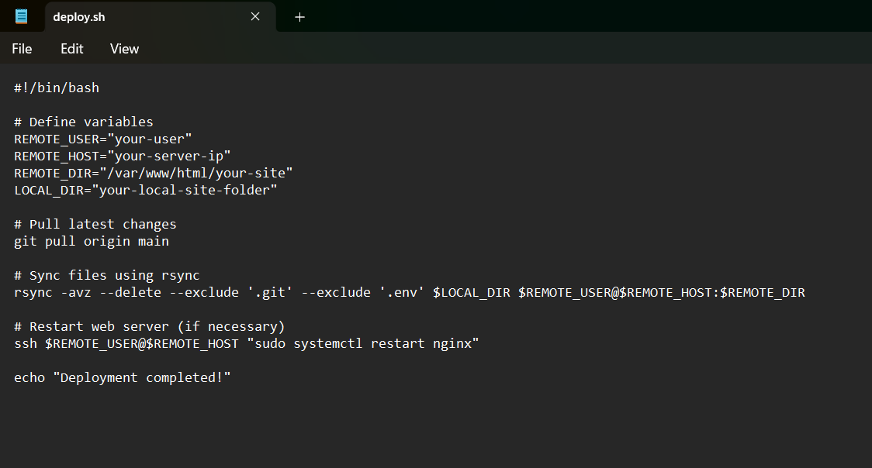

**4. Automate Deployment on Git Push**

Modify the post-receive hook on the remote server:

**mkdir -p ~/deploy-hooks**

**nano ~/deploy-hooks/post-receive**

then add, to the powershell

**#!/bin/bash**

**GIT_WORK_TREE=/var/www/html/your-site git checkout -f**

**git remote add production user@your-server:/path/to/repo.git**

**git push production main**

**5. Add a Git Hook for Auto Deployment**

In your local project, create a Git hook (.git/hooks/post-commit) and make it executable:

**#!/bin/bash**

**./deploy.sh**

**chmod +x .git/hooks/post-commit**

**6. Test the Setup**

Make a change to your local files, commit, and push:

**sh**

**CopyEdit**

**git add .**

**git commit -m “Updated website”**

**git push**

Check your server to confirm that the changes were deployed.

**Outcome:**

With this setup, your static website will update automatically whenever you push changes to your repository .